TECHNICAL REPORT
19902 Altaire ll Anti-decubitus mattress system

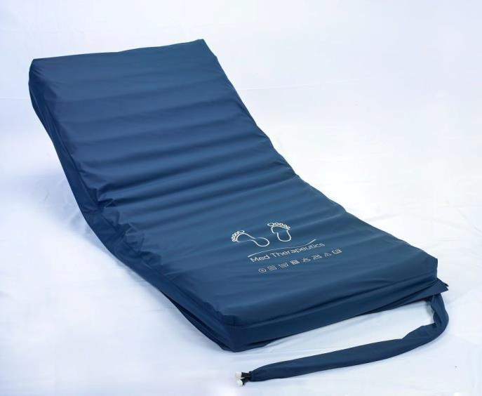
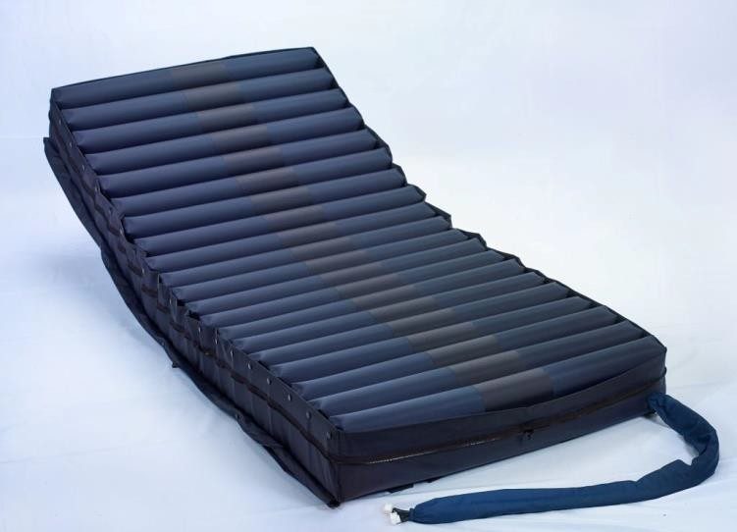

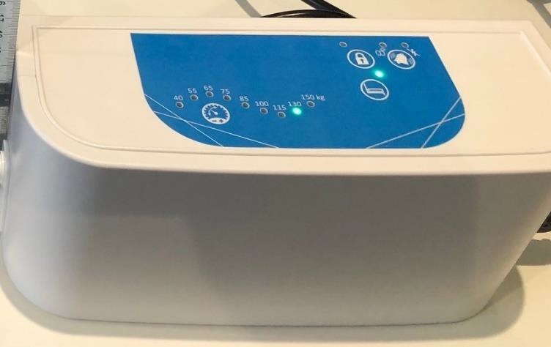

1. Product description
1.1. Intended use ……………………………………………….…… | 2
1.2. System description ..……………………………………….…… | 2
1.2.1. Anti-decubitus surface .…………………………...……… | 3
1.2.2. Cover …….………………………..……….……………… | 3
1.2.3. Pump ……………………………………………….…. | 3
2. Datasheet …………………………………………………..………… | 6
2.1.Mattress specifications & 2.1.1 cover specification............................ | 6
2.2 Pump specifications 6
2.3.Washing prescriptions and system sanification …………….…... | 6

CE Marking and EC directives 6

    - PRODUCT DESCRIPTION

Intended use
19902 ALTAIRE II is a dynamic anti-decubitus mattress system using an air mattress made from nylon & polyeurathane and powered by an air pump to redistribute pressure across the surface of the mattress to avoid vascular compression particularly on areas of bony protrusion such as heels or the sacrum . It is a dynamic surface indicated for the prevention of decubitus ulcers up to stage III and it is available for patients up to 180 Kg. The particular structure of the mattress, its modularity and flexibility make it adaptable to all kind of profiling beds in a domestic or hospital environment.
To use properly the mattress, we suggest to call on competent or paramedical/medical staff. According to D. Lgs. 81/2008, the surface can be managed in complete safety.

System description
19902 ALTAIRE II mattress system (Fig. 1) is composed by a dynamic anti-decubitus mattress with its cover and a pump that powers the mattress. The mattress can be positioned directly on the bed structure to replace the traditional mattress and it can also fit electrical adjustable bed movements. Thanks to the serigraphy printed on the cover, it is very easy to recognize the upper side of the mattress 19902 ALTAIRE II and unlike traditional mattresses, 19902 ALTAIRE II must not be periodically flipped. The Air pump ALTAIRE II has an internal air compressor to deliver 8 litres of an air per minute through the two air ports on the side of the pump to inflate the mattress.
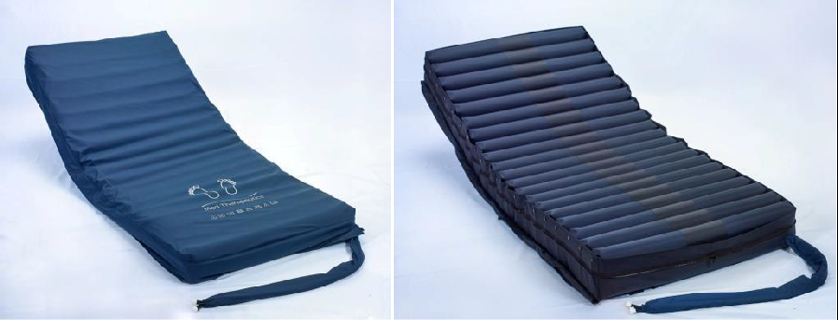
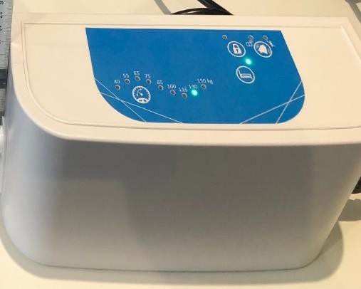

Figura 1. 19902 ALTAIRE II

Antidecubitus mattress
The 19902 ALTAIRE II anti-decubitus mattress is made of three different layers that perfectly adapt to the body shapes and guarantee lower values of contact pressures while providing a high comfort level.
The first bottom layer is the mattress base made from Nylon and holds within its walls and base the second and dynmaic part of the mattress.The second part is a series of up to 17 cells made from polyeurythene that alternately fill with air to provide support but then after 5 minutes empty out to give pressure relief whilst the cell next to it fills with air to give support. The first cell from the foot end of the mattress and each alternate cell are known as A cells and the cells inbetween are known as B cells with A & B cells alternately giving support or relief. The modular structure of the cells mean that the mattress profiles to most hospital & nursing beds. The third and last layer is the cover which has high stretch properties to help it conform to patient movements
The bearing structure is made of PU. All Polyurethane material used are Latex-free, Phthalate-free and fire retardant.
The system is totally radiotransparent.

Cover
The upper cover is made of Polyester-Polyurethane .This particular material used is bi-elastic (with a low friction coefficient), waterproof and resistant to body fluids, vapour perspirant, fire resistant, smell and spot repellent, anti-bacterial, anti-fungal, antistatic, Latex-free and Phthalate-free.
The entire cover is easy to be removed from the mattress and it is interchangeable through a zip, which is properly covered by a flap; The cover is easily cleanable .Clinical tests on the upper cover confirm that the material doesn’t produce any kind of allergic reaction. Further details are reported in the data sheet section. Tests also show that the cover is completely non-toxic for patient’s skin and oral tract.

        - Pump

The ALTAIRE II pump is a Medical Device Class 1 when used in conjuction with mattress 19902 ALTAIRE II . It is a 220V-240V 50HZ mains powered pump using a quiet internal air compressor to alternatively deliver air to the mattress 19902 ALTAIRE II A cells and then by use of the internal rotor valve it will then 5 minutes later deliver air to mattress 19902 ALTAIRE II B cells using the two A&B air ports on the side of the pump. Use of intelligent pressure sensing technology means that the pump switches off when the optimum internal pressure is reached. Weight of the patient is entered using the dial to correctly reach the best internal pressure.
Power consumption | 7W (Altaire ll 7W)
Fuse rating | F2A 250VAC
Electrical isolation | Class I 2a
Ingress protection | IP21
IEC conformity | 60601-1, 60601-1-2, 60601-11
Warranty | 2 years against all manufacturing faults

DATASHEET

Manufacturer | Sequoia Healthcare
Production date | 2021
Device | Anti-decubitus dynamic mattress system
Mattress Type | Dymanic mattress system (powered)
Classification, according to  93/42/CEE | Medical device Class I
Intended use | Prevention of decubitus ulcers up to stage III
Conformity | 93/42/CEE and subsequent modifications and additions UNI EN ISO 13485 and UNI EN ISO 9001  Medical Devices Directive 2007/47/EC
Warranty | 2 years (for both the mattress, pump )

Mattress specifications

System description | Anti-decubitus dynamic mattress system (powered by its supporting air pump) mattress made from PU cells to support the patient and alternatively give support and pressure relief and encased in Nylon base & PU zipped cover  Latex and Phthalate free. Completely radiotransparent device.
Mattress standard size | 198 x 88 x 12cm (non-standard size on request)
Device’s weight | 6 Kg
Maximum supported weight | 150 Kg
Fire resistance | Component materials (Polyurethane and the entire cover) are certified by the manufacturer as fire resistant

2.2.1 Cover specifications

Composition | Upper cover: Polyester-Polyurethane; it is antifungal, antibacterial, breathable to water steam, waterproof and resistant to liquids, smell and  spot repellent, fire resistant and machine washable. Latex and Phthalate free.
MECHANICAL AND PHYSICAL PROPERTIES OF UPPER COVER |  | STANDARD
Waterproofness | > 3000 mm | EN ISO 811
Breathability | >= 600 g/m2 x 24 h at 38° | ASTM E96
Fire standard | CRIB 5 | BS 6807- BS 7175
Notes | - Permanent antimycotic and antibacterial barrier; moisture resistant  - Resistant to all organic fluids  - Washing prescriptions are printed on the cover

- 2.2 Pump specifications

Pump description | Anti-decubitus dynamic pump. Connects to the mattress via quick release connectors . Two air ports alternatively deliver air to the A cells and then after 5 minutes the B cells through the two hoses at the foot end of the mattress  .
Pump standard size | 24cm wide x 11.5cm high x 9cm deep. 2.2kg
Device’s weight | 2.2KG

    - Cover specifications

Composition | Upper cover: Polyester-Polyurethane; it is antifungal, antibacterial, breathable to water steam, waterproof and resistant to liquids, smell and  spot repellent, fire resistant and machine washable. Latex and Phthalate free.
MECHANICAL AND PHYSICAL PROPERTIES OF UPPER COVER |  | STANDARD
Waterproofness | > 3000 mm | EN ISO 811
Breathability | >= 600 g/m2 x 24 h at 38° | ASTM E96
Fire standard | CRIB 5 | BS 6807- BS 7175
Notes | - Permanent antimycotic and antibacterial barrier; moisture resistant  - Resistant to all organic fluids  - Washing prescriptions are printed on the cover

2.1. Washing prescriptions and system sanification (figure 1)

Cover washing prescriptions | - Machine washable up to 70°C(*) with a proper non aggressive cleaning agent  - The normal cleaning instructions are to wipe the surface clean with a soft sponge or soft cloth with warm soapy water  The upper cover can tolerate Chlorine releasing agents at maximum 1,000 Parts Per Million (0.1% ppm); whenever Chlorine solution is used, the cover must be washed afterwards with water so the chlorine residue does not stay on it. However, please be aware that the stronger is Chlorine solution used (max 0.1% ppm) the higher rate of upper cover replacement will be required in time.
Disinfection | The cover can be sanitized in autoclave at a temperature of 134°C for 3 minutes; please first clean the surface with pure water

(*) A temperature of 60°C is suggested to perform an effective disinfection while better preserving the serigraphy and the material over time.

2.3 Specifications

Technical Specifications |  | Atmospheric Specifications
Therapy modes | Dynamic & Static | Storage temperature | -25 - 70°C
Compressor air flow | Approx. 8lpm | Transport temperature | -25 - 70°C
Cycle time | 10 minutes | Operating temperature | 5 - 40°C
Anti-particle filter | Yes | Humidity | 10 - 90%
Visual and audible  alarms | Yes | Atmospheric pressure | 700 - 1060hPa
Electrical power supply |  | 220 – 240V / 50Hz
Power consumption |  | 7W (Airwave 1010: 8W)
Fuse rating |  | F2A 250VAC
Electrical isolation |  | Class I 2a
Ingress protection |  | IP21
IEC conformity |  | 60601-1, 60601-1-2, 60601-11
Warranty |  | 2 years against all manufacturing faults

CE marking
CE Marking indicating conformance to EC Directive No. 2007/47/EC concerning medical devices
Type BF Applied Part (patient isolation from electrical shock)
Class II Product
Indicates separate collection for electrical and electronic equipment (WEEE) IP Protection rating: IP21 – protection against finger and dripping water

